Web Server Lab Setup for Penetration Testing

posted in[**Penetration Testing**](https://www.hackingarticles.in/category/penetration-testing/) on [**May 3, 2019**](https://www.hackingarticles.in/web-server-lab-setup-for-penetration-testing/) by [**Raj Chandel**](https://www.hackingarticles.in/author/raaz/)

SHARE

Save

In this post, we will discuss how to set-up our own web server for penetration testing on Ubuntu 18. Ubuntu 18 has updated with the new features.

**Table of Content**

**Requirement**

**Web Server configuration**

* Apache
* PHP
* MySQL
* phpMyAdmin
* FTP
* SSH
* Nmap

**Requirement-ubuntu 18.0**

**Web Server Configuration**

The Web server is a program that uses HTTP to serve users with files forming web pages in response to requests transmitted by their HTTP clients.

The Web servers can also be called dedicated computers and apparatuses.

**Install Apache**

First, we will install the Apache. Apache is the most commonly used Web server on Linux Systems. Web servers are used to serve web pages requested by the client computers. So, let’s first install Apache in the ubuntu by the following command-



|  |  |
| --- | --- |
| 1 | apt install apache2 |

 We have successfully installed apache2, by default apache runs on port 80.

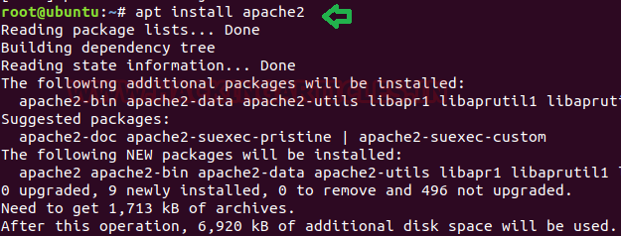

**Install PHP**

Now we will install PHP 7modukle for Apache 2 and for all of its dependencies. Earlier we used to install PHP 5 module for Ubuntu 14. But now as it is not compatible in ubuntu 18.so we will install the latest version of php which is php7.2 For this run the following command in ubuntu terminal-



|  |  |
| --- | --- |
| 1 | apt install php7.2 |

As you can see, we have done with php installation.

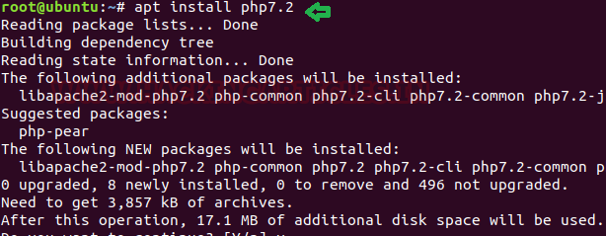

**Install MySQL** **Server**

Now comes the next step which is the installation of MySQL server. MySQL is the famous open-source database which was very easier to install earlier. But now it requires some changes for Ubuntu 18.

So, let’s go ahead step by step.

First, we will install MySQL server by the following command-



|  |  |
| --- | --- |
| 1 | apt install mysql-server |

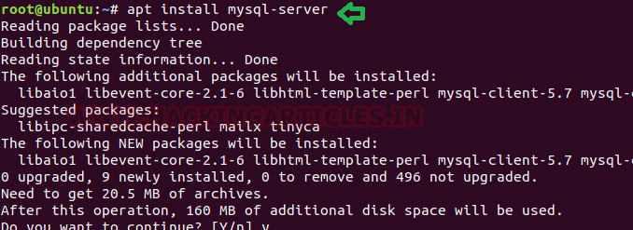

So, we are done with the installation. In Ubuntu 14, MySQL did not need a password as it required only the root user to logged in. But now it needs a password and it won’t allow the root user to log in so we will provide a username and password of ubuntu in MySQL with the following command and as it will ask for the password; you have to use your ubuntu password here. After it gets logged in you will grant all the privileges to the user of Ubuntu as in our case we have given all the privileges to user raj which will be identified with the password of ubuntu which is 123 in our case and after which we will reset all the previous privileges so that it can start the service with the new changes. For this, the commands are the following.



|  |  |
| --- | --- |
| 1  2  3 | mysql -u root -p  GRANT ALL PRIVILEGES ON *.* TO 'raj'@'%' IDENTIFIED BY '123' WITH GRANT OPTION;  flush privileges; |

Great we are done with MySQL server installation, by default it runs on port 3306, now restart MySQL service.



|  |  |
| --- | --- |
| 1 | service mysql restart |

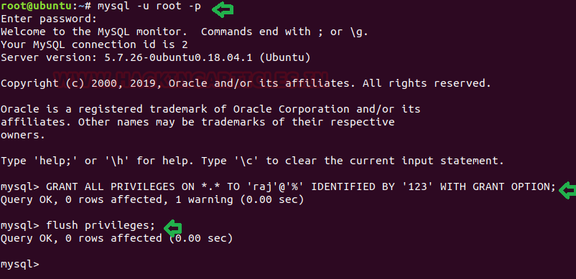

**Install phpMyAdmin**

 Now the next step is the installation of a phpMyAdmin software tool which is written in PHP and which is proposed to handle the administration of MYSQL over the WEB and it also supports a wide range of operations on MYSQL. First, we need to install phpMyAdmin by the following command-



|  |  |
| --- | --- |
| 1 | apt install phpmyadmin |

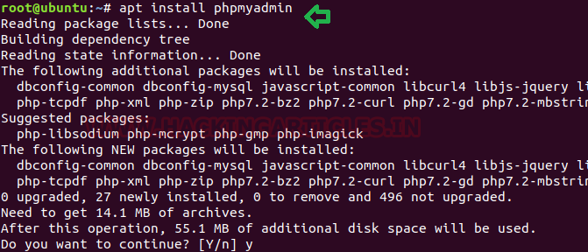

After the installation, it will ask you to choose the web server. Here you need to choose apache2 which will automatically be configured to run phpmyadmin.

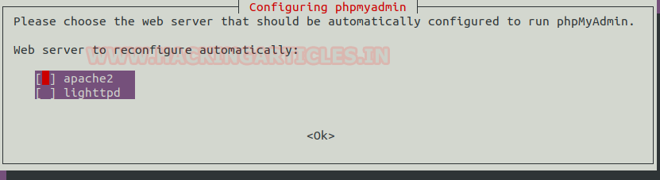

Next, you will get a prompt which will be opened to configure a database for phpmyadmin with dbconfig-common. Here you need to click on yes and the enter.

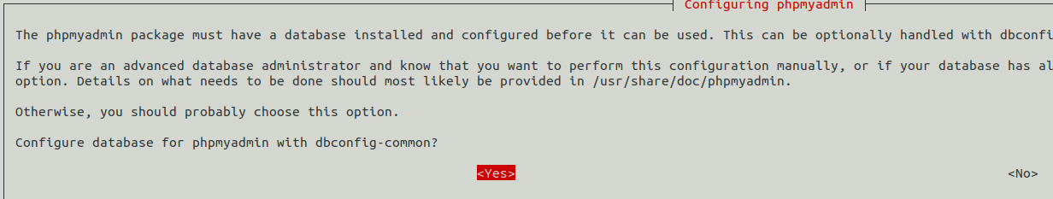

 Again, you will get a prompt which will ask you to submit the password for phpMyAdmin, to register with the database server. Here we have given 123 as the password as it is essential to give it a password now.

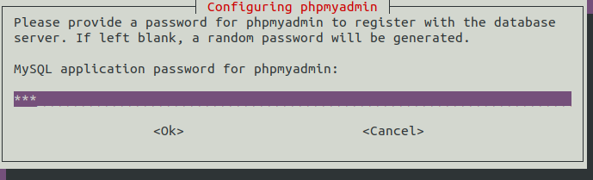

The next step is the configuration of phpmyadmin under apache, for this we need to edit apache2 conf file by adding two lines at the end of this file:



|  |  |
| --- | --- |
| 1 | nano /etc/apache2/apache2.conf |



|  |  |
| --- | --- |
| 1  2 | #phpMyAdmin Configuration  Include /etc/phpmyadmin/apache.conf |

At the last, as shown in the image below and then save it and after the editing saves the file and restart apache2 service.



|  |  |
| --- | --- |
| 1 | service apache2 restart |

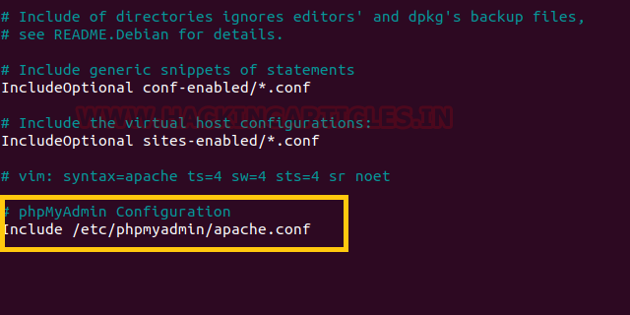

Now open phpmyadmin in the browser as localhost/phpmyadmin as shown in the image below-

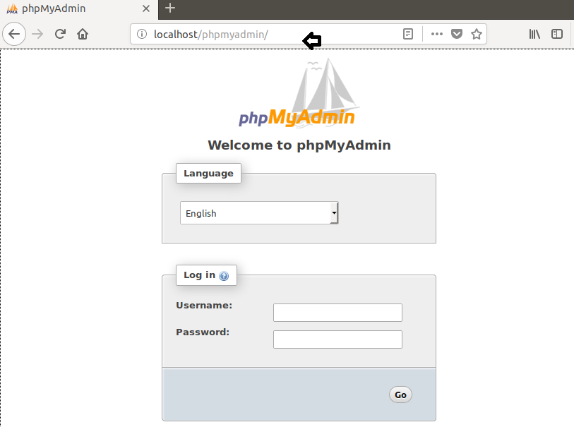

**Install ftp**

 Now we will install FTP server in ubuntu which is used for the transfer of computer files between a client and server on a computer network. For this run the following command in the terminal-



|  |  |
| --- | --- |
| 1 | apt install vsftpd |

As we can see in the above screenshot that ftp service has been installed in our system which runs on port 21

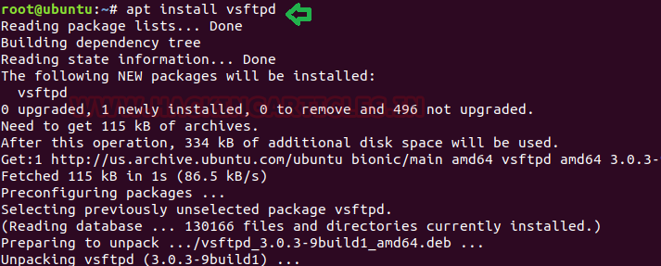

**Install ssh**

Now the next is SSh protocol which is method for secure remote login from one computer to another.so lets install this service by the following command. It is installed successfully; by default, it runs on port 22.



|  |  |
| --- | --- |
| 1 | apt install openssh-server |

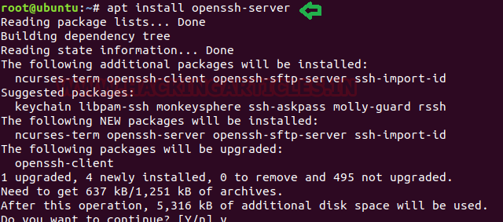

**Install Nmap**

Now in order to check that the above services have been installed properly in our system; we will use nmap which is a scanner for ports and which tells us about the open ports and running services status.

So, let’s install that by the following command-



|  |  |
| --- | --- |
| 1 | apt install nmap |

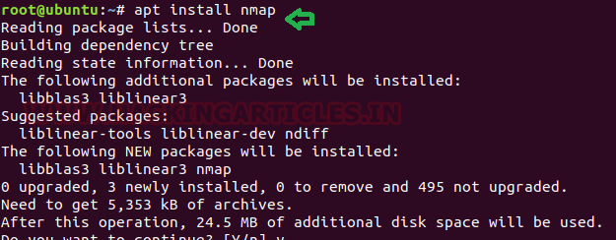

Once the installation is done, we will scan our own system by the following command and it will scan our system and will come up with the desired results as you can see in the image given below-



|  |  |
| --- | --- |
| 1 | nmap 127.0.0.1 |

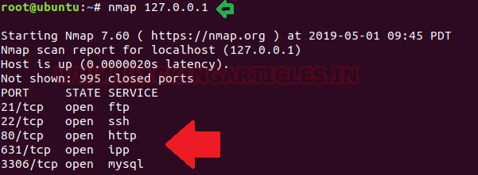

**Author**: Geet Madan is a Certified Ethical Hacker, Researcher and Technical Writer at Hacking Articles on Information Security**.**Contact [**here**](https://www.linkedin.com/in/geet-madan-86568b170/)